**VIDADAL SRI RAM**

**192211702**

**CSA-1540**

**CLOUD COMPUTING AND BIG DATA**

**ANALYTICS FOR CLOUD SECURITY……**

1. **Create a simple cloud software application for Car Booking Reservation System using any Cloud Service Provider to demonstrate SaaS.**

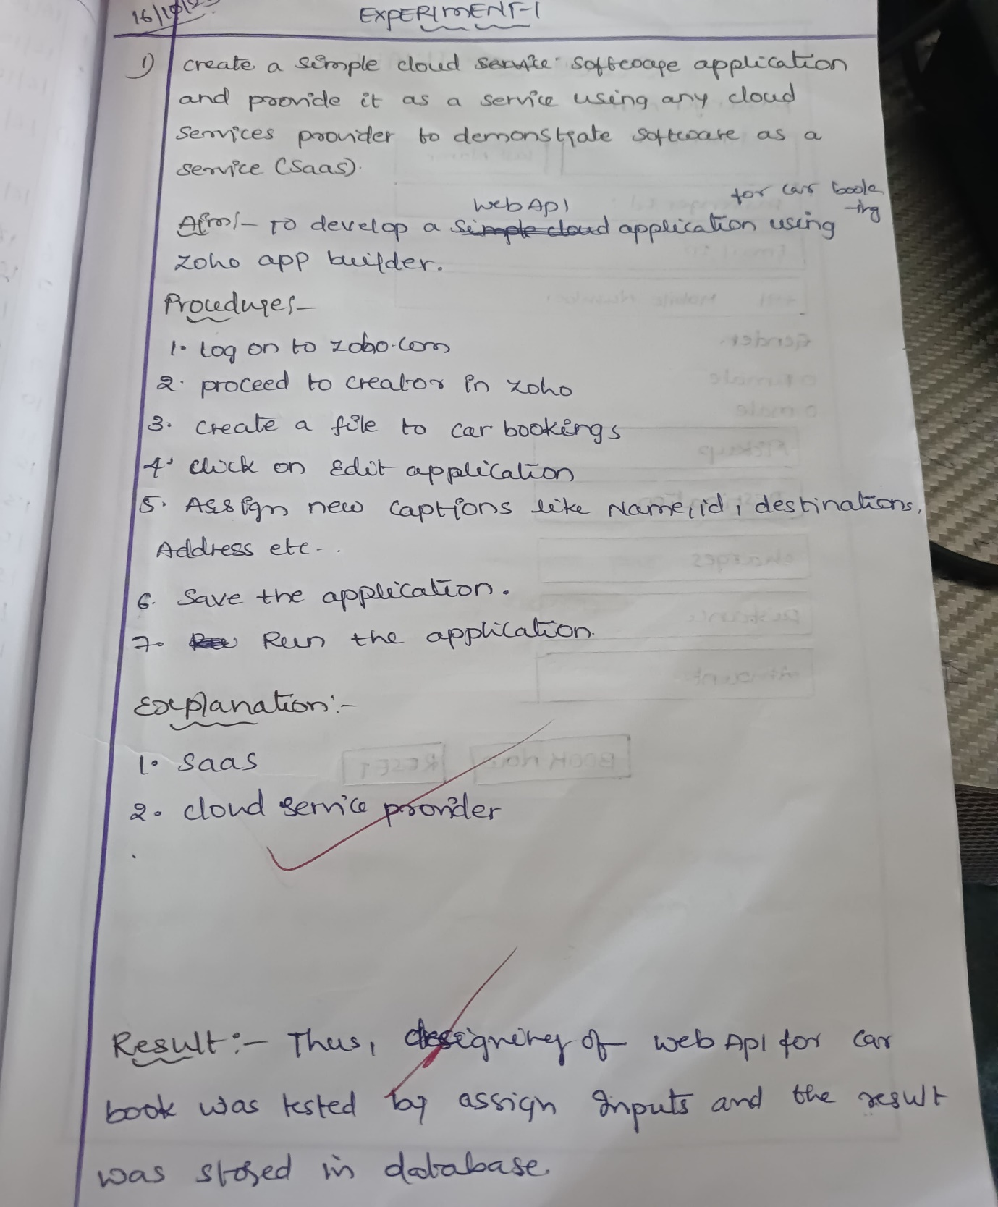

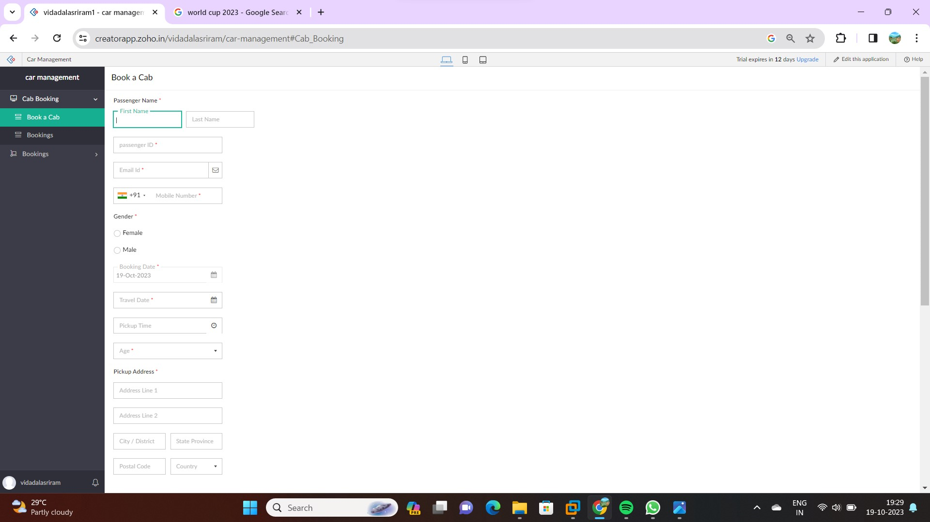

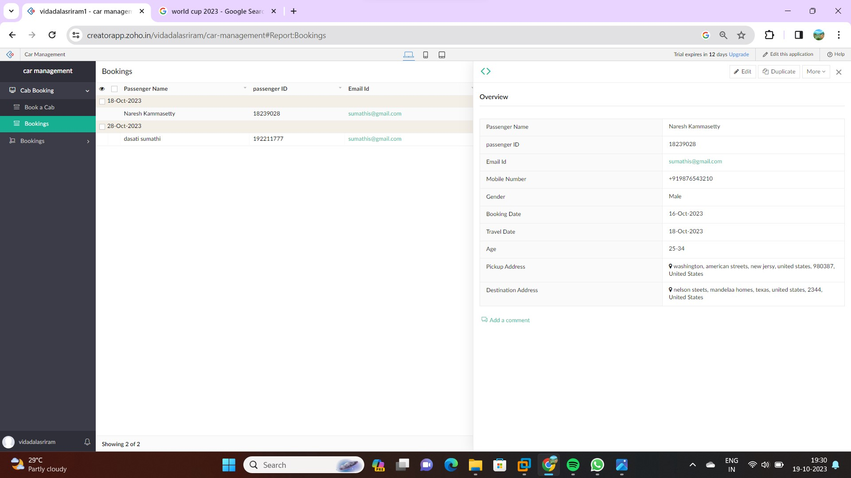

1. **Create a simple cloud software application for Flight Reservation System using any Cloud Service Provider to demonstrate SaaS**

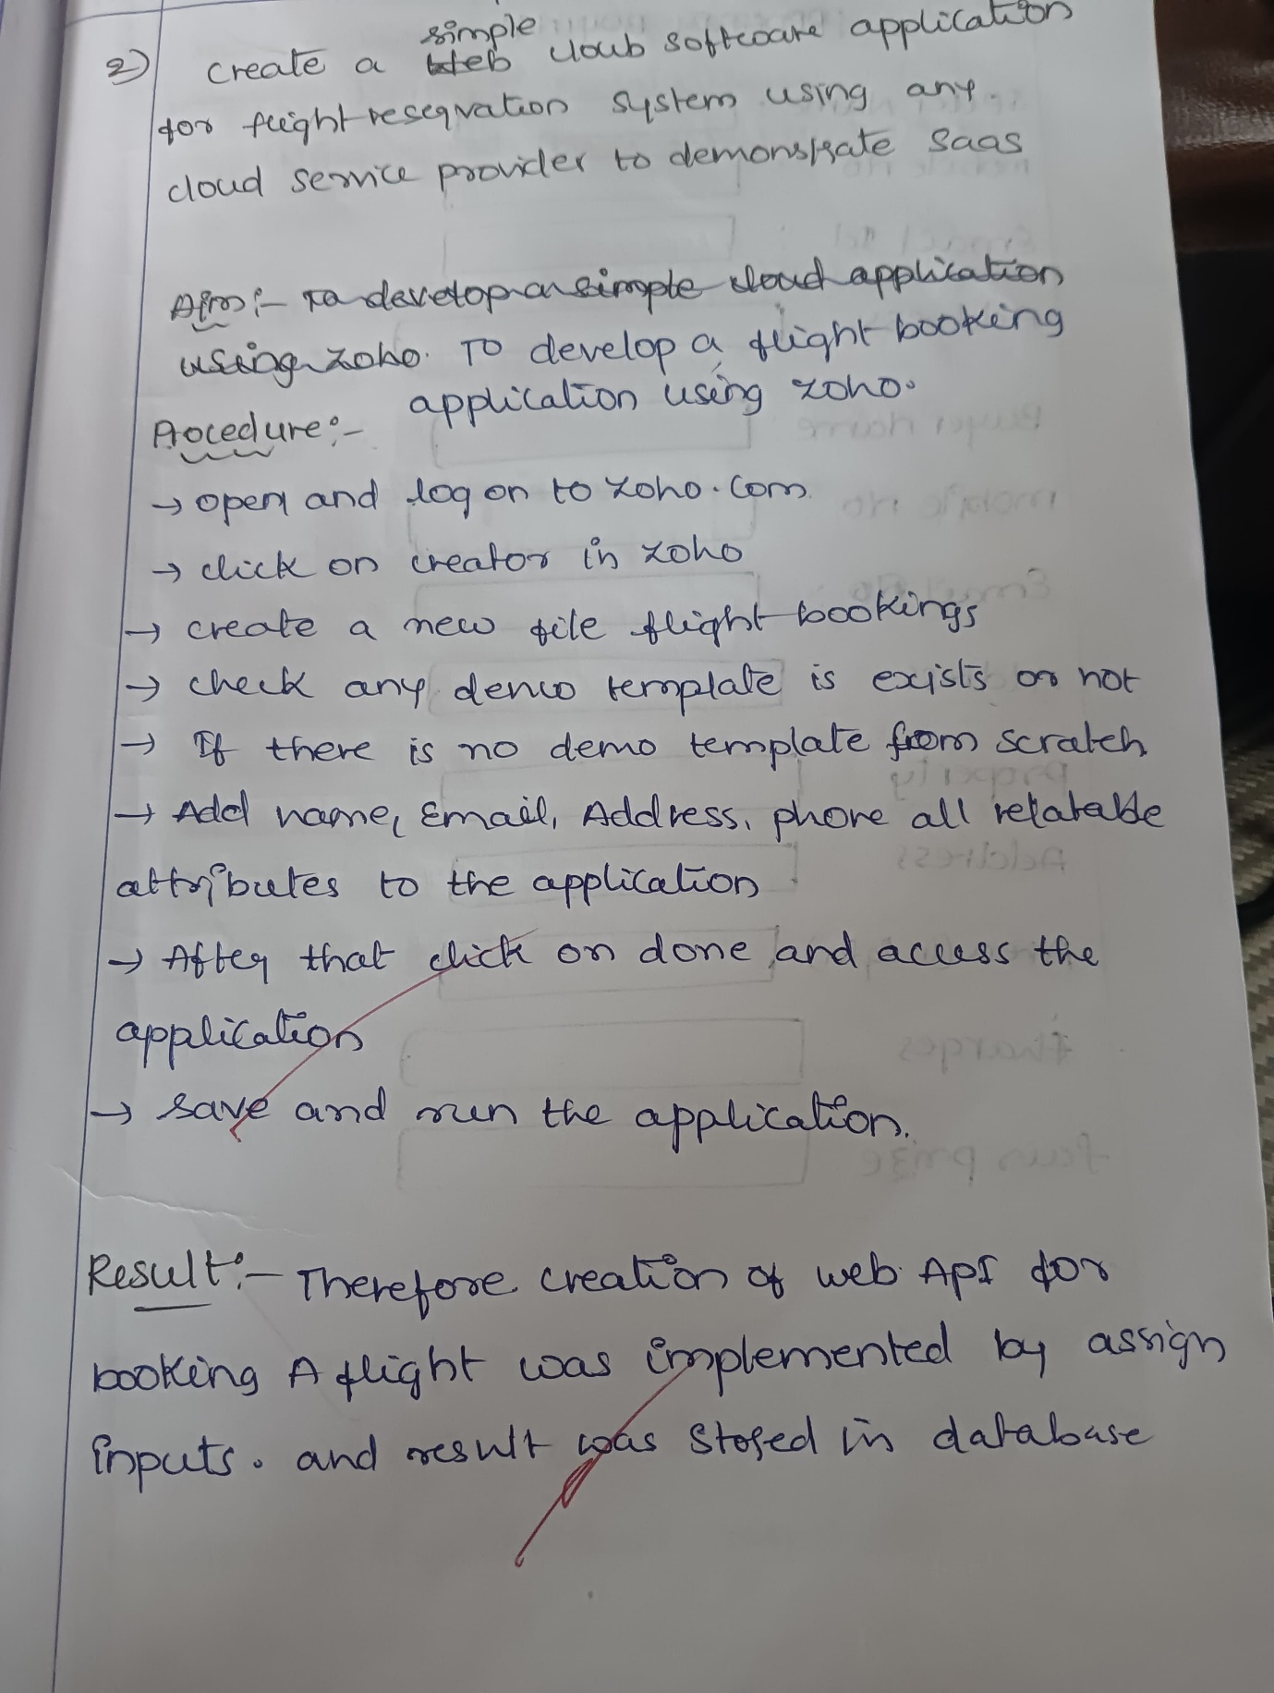

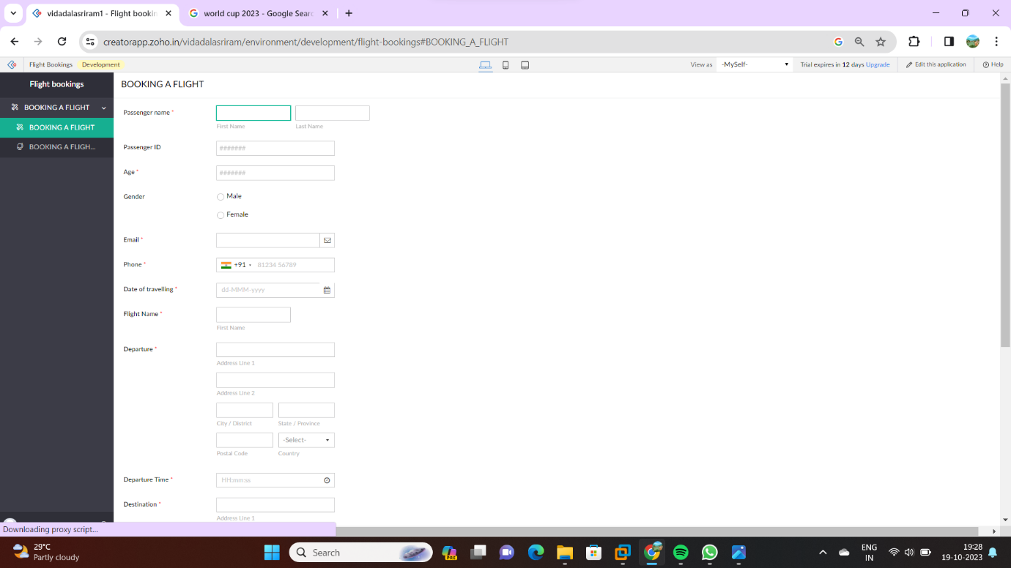

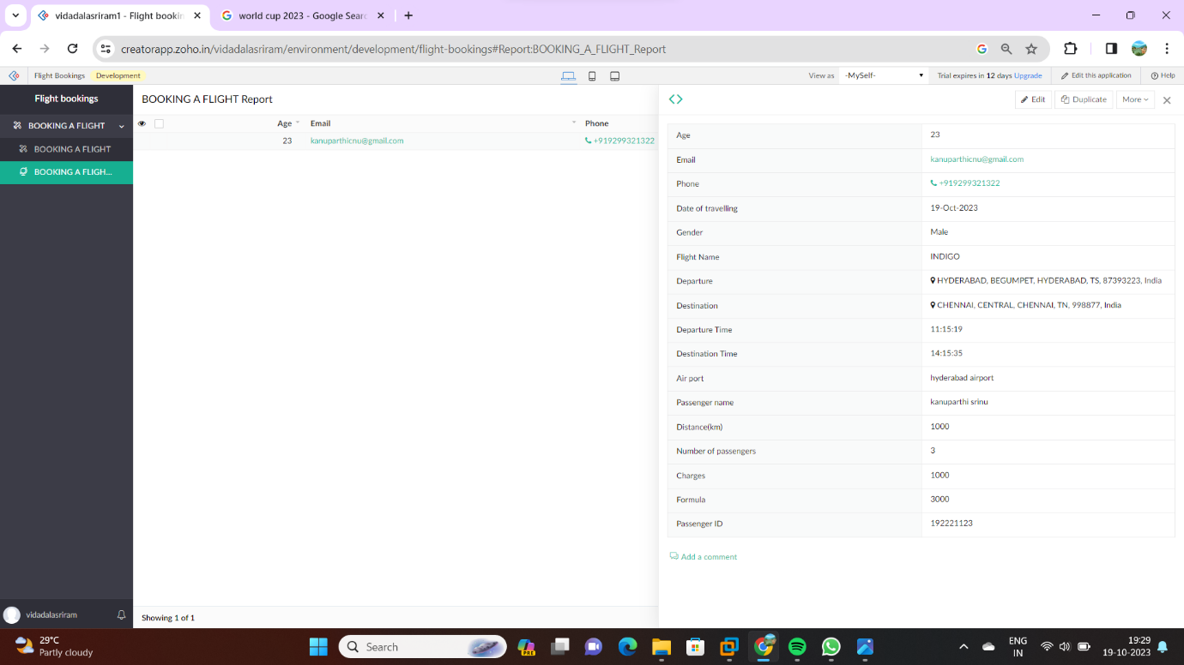

1. **Create a simple cloud software application for Property Buying & Rental process (In Chennai city) using any Cloud Service Provider to demonstrate SaaS**

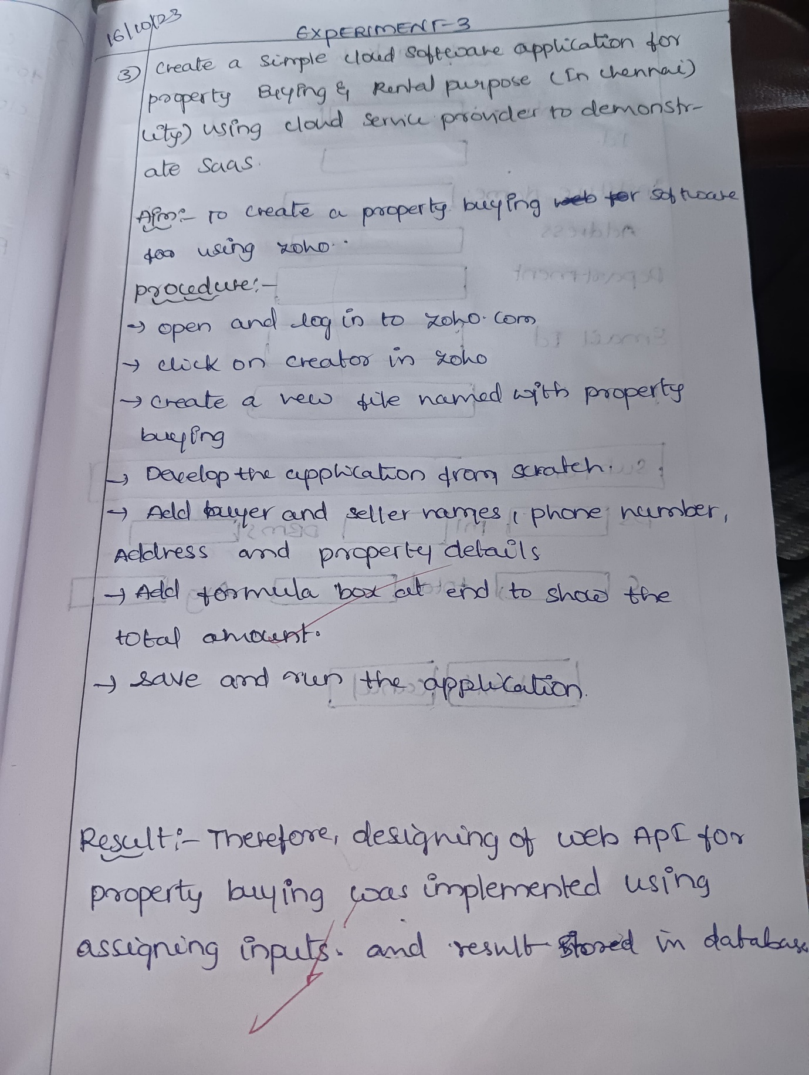

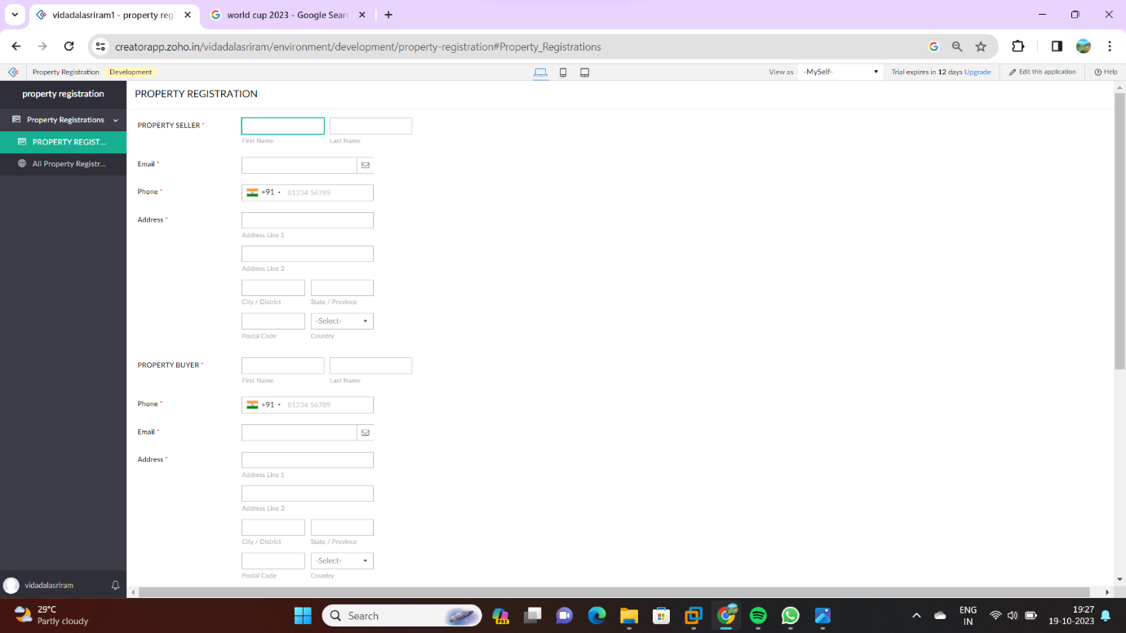

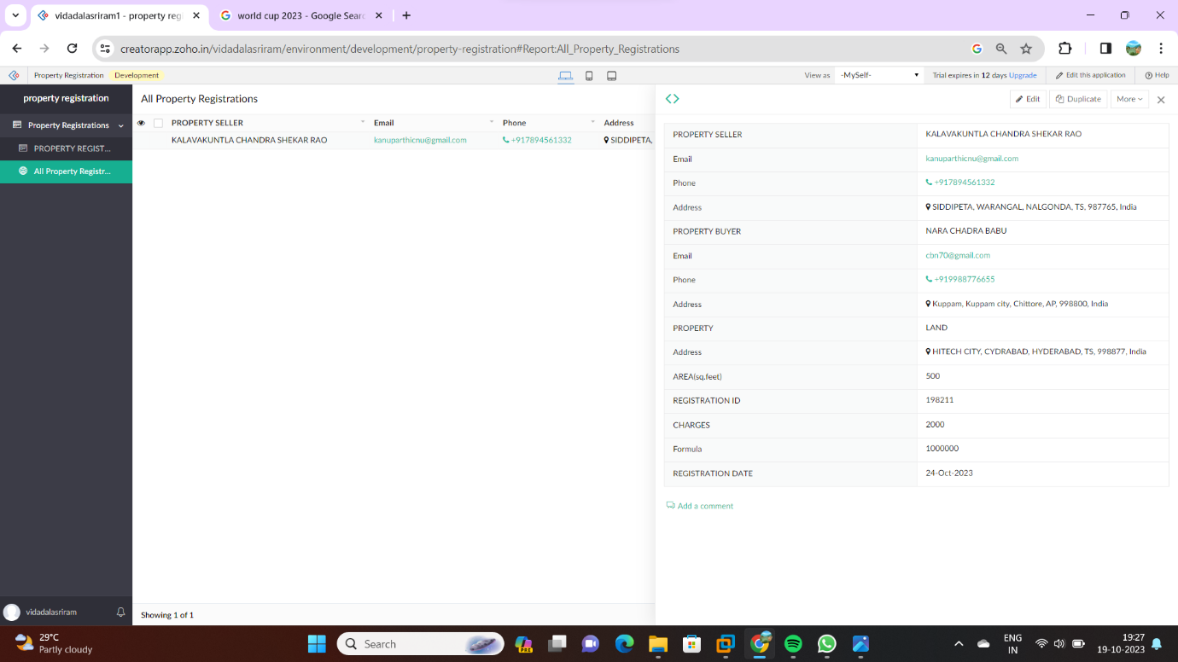

1. **Create a simple cloud software application for Students marks list using any Cloud Service Provider to demonstrate SaaS**

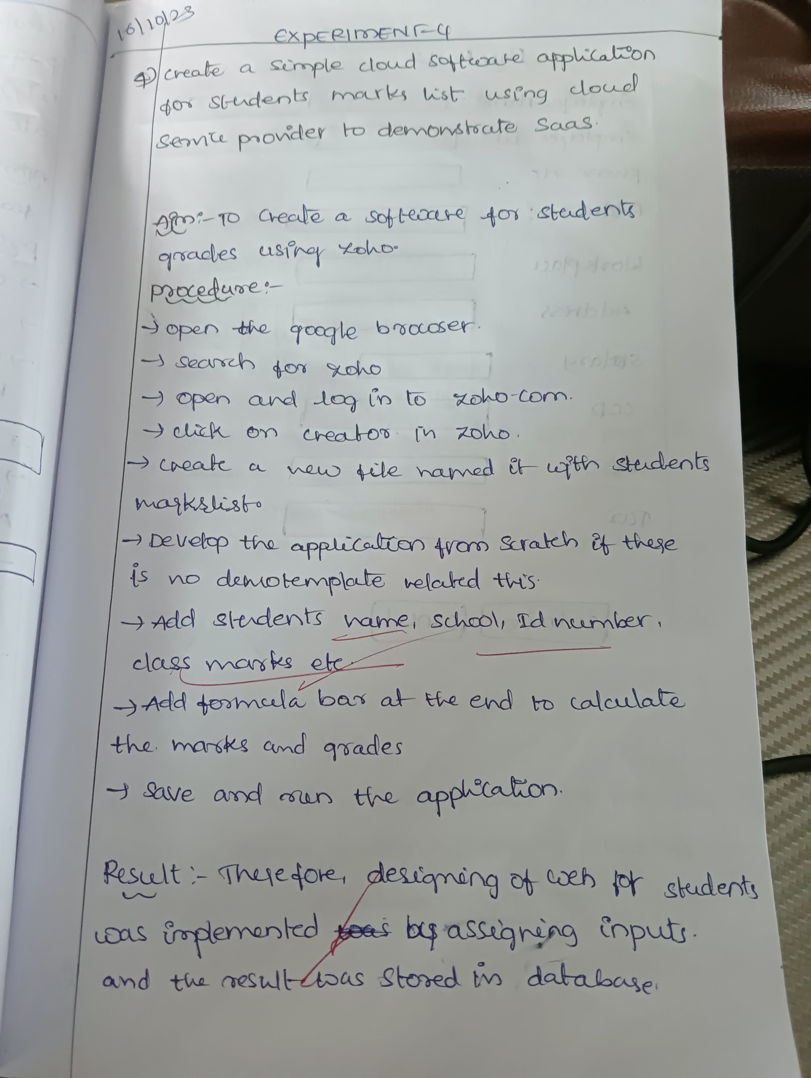

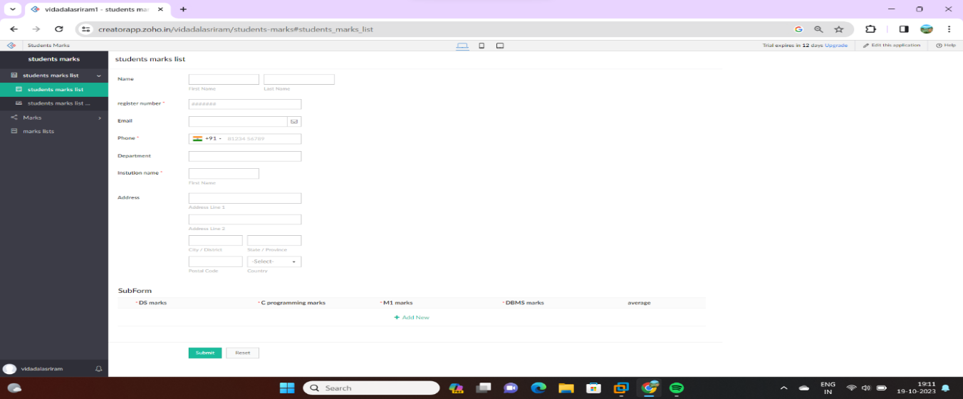

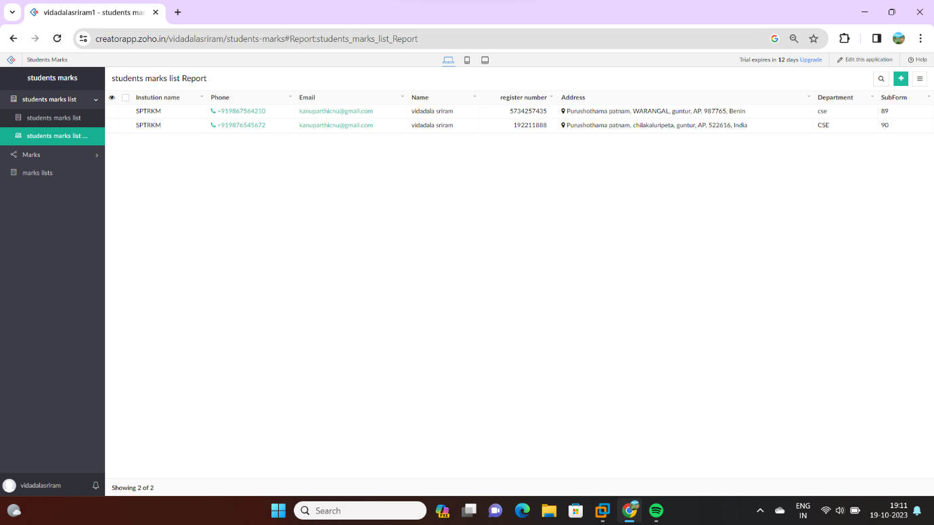

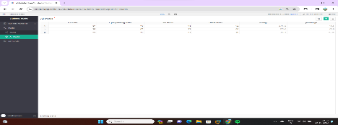

1. **Create a simple cloud software application for Pay role of employee using any Cloud Service Provider to demonstrate SaaS**

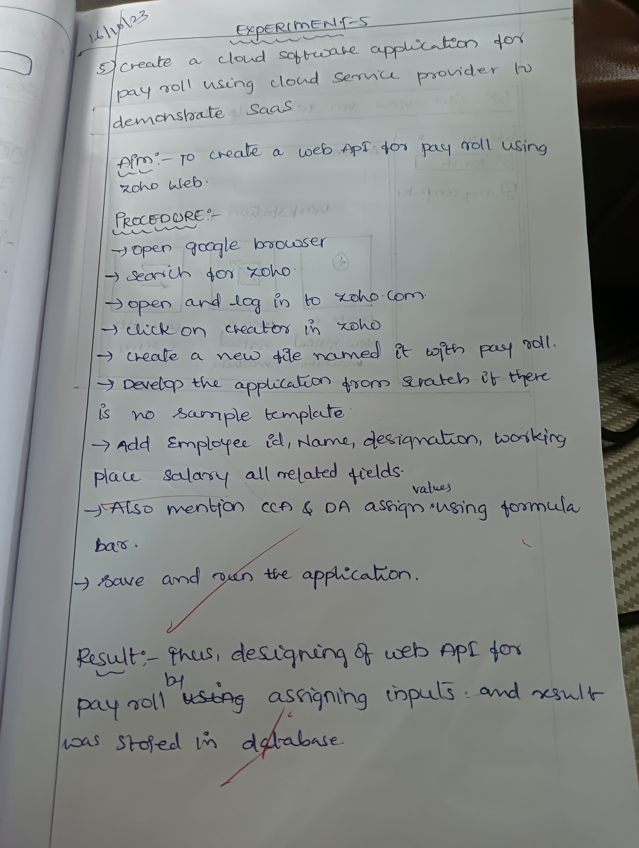

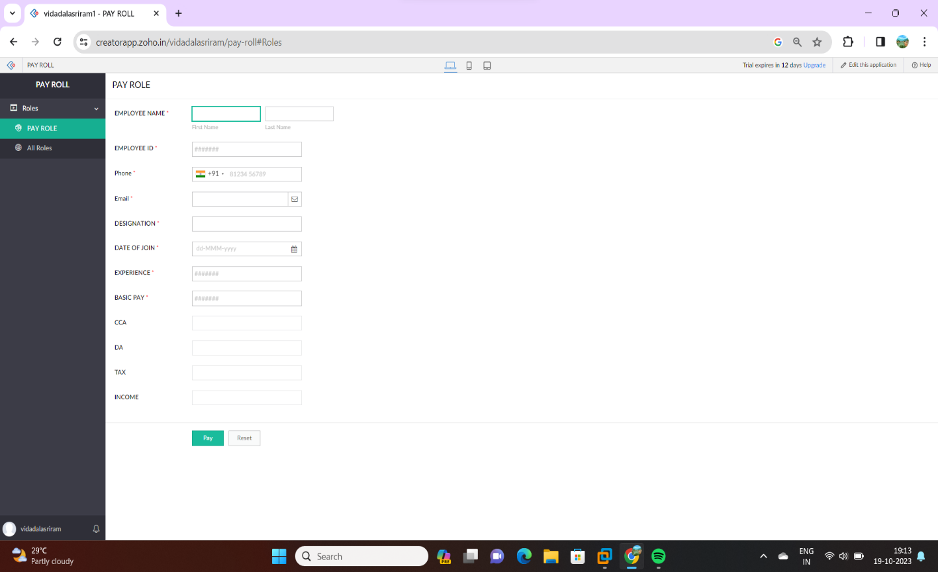

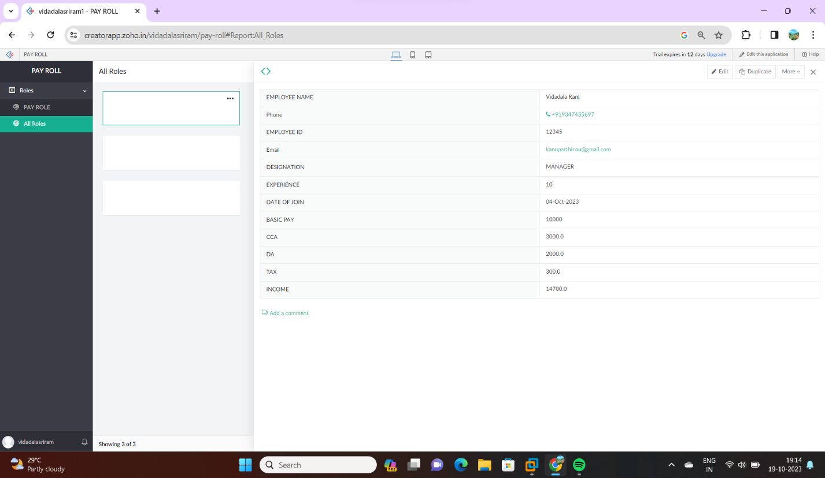

1. **Create a simple cloud software application for Library book reservation system for SIMATS library using any Cloud Service Provider to demonstrate SaaS**

